

**EXPERIMENT NO:02**

**Aim:** Sketch a DFD Diagram up to 2 level for our project

**Theory:** A data flow diagram (DFD) maps out the flow of information for any process or system. It uses defined symbols like rectangles, circles and arrows, plus short text labels, to show data inputs, outputs, storage points and the routes between each destination. Data flowcharts can range from simple, even hand-drawn process overviews, to in-depth, multi-level DFDs that dig progressively deeper into how the data is handled. They can be used to analyse an existing system or model a new one. Like all the best diagrams and charts, a DFD can often visually “say” things that would be hard to explain in words, and they work for both technical and nontechnical audiences, from developer to CEO. That’s why DFDs remain so popular after all these years. While they work well for data flow software and systems, they are less applicable nowadays to visualizing interactive, real-time or database-oriented software or systems.

Data flow diagrams were popularized in the late 1970s, arising from the book *Structured Design*, by computing pioneers Ed Yourdon and Larry Constantine. They based it on the “data flow graph” computation models by David Martin and Gerald Estrin. The structured design concept took off in the software engineering field, and the DFD method took off with it. It became more popular in business circles, as it was applied to business analysis, than in academic circles.

Also contributing were two related concepts:

* Object Oriented Analysis and Design (OOAD), put forth by Yourdon and Peter Coad to analyze and design an application or system.
* Structured Systems Analysis and Design Method (SSADM), a waterfall method to analyze and design information systems. This rigorous documentation approach contrasts with modern agile approaches such as Scrum and Dynamic Systems Development Method (DSDM.)

Three other experts contributing to this rise in DFD methodology were Tom DeMarco, Chris Gane and Trish Sarson. They teamed up in different combinations to be the main definers of the symbols and notations used for a data flow diagram.

Using any convention’s DFD rules or guidelines, the symbols depict the four components of data flow diagrams.

1. **External entity:** an outside system that sends or receives data, communicating with the system being diagrammed. They are the sources and destinations of information entering or leaving the system. They might be an outside organization or person, a computer system or a business system. They are also known as terminators, sources and sinks or actors. They are typically drawn on the edges of the diagram.
2. **Process:**any process that changes the data, producing an output. It might perform computations, or sort data based on logic, or direct the data flow based on business rules. A short label is used to describe the process, such as “Submit payment.”
3. **Data store:** files or repositories that hold information for later use, such as a database table or a membership form. Each data store receives a simple label, such as “Orders.”
4. **Data flow:** the route that data takes between the external entities, processes and data stores. It portrays the interface between the other components and is shown with arrows, typically labeled with a short data name, like “Billing details.”

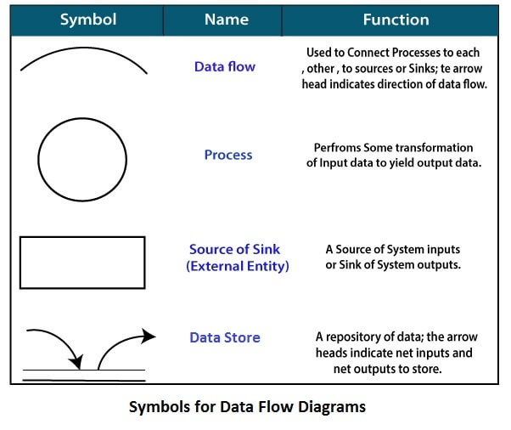

* **DFD Diagram for Bank Management System:**

**DFD Diagram for level 0**

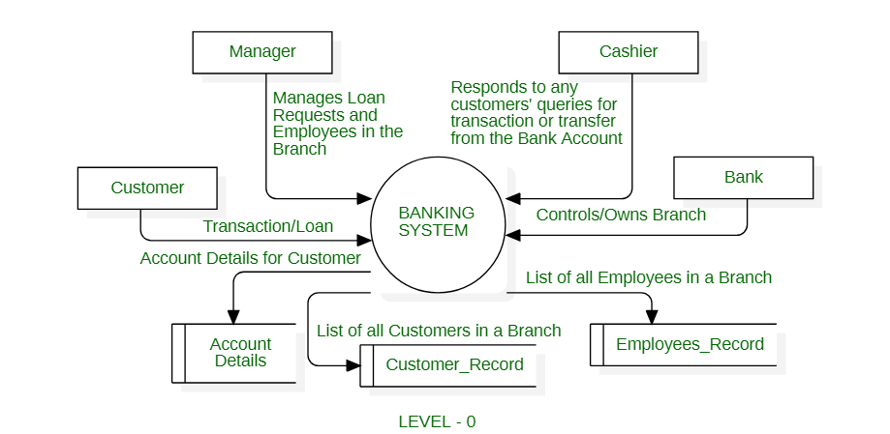

**DFD Diagram for level 1**

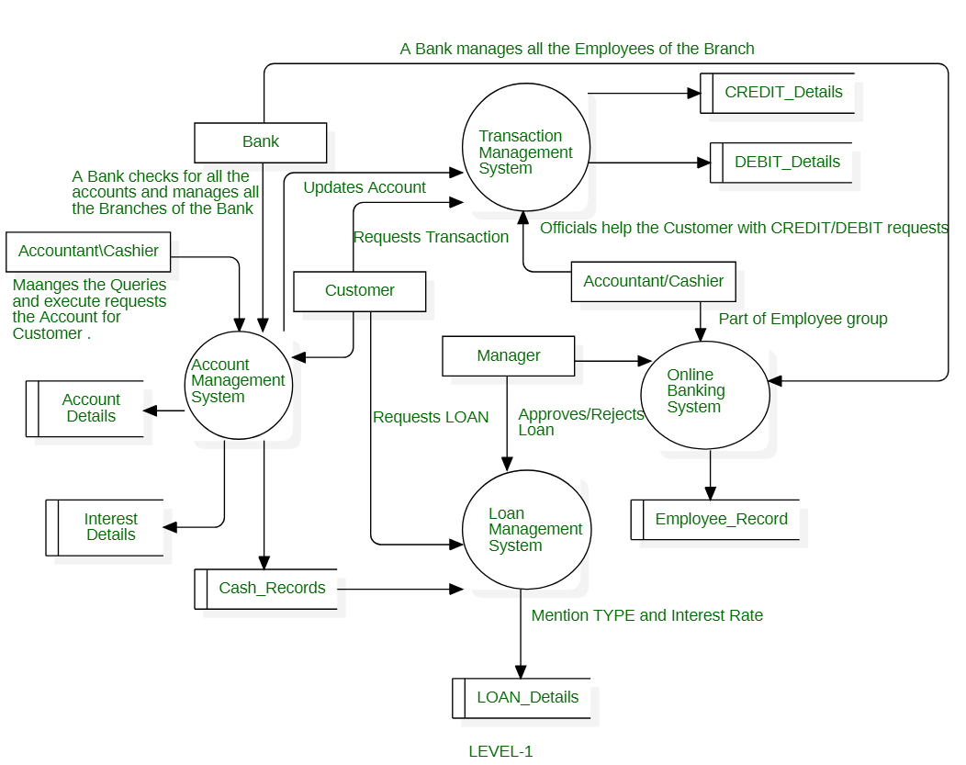

**DFD Diagram for level 2**

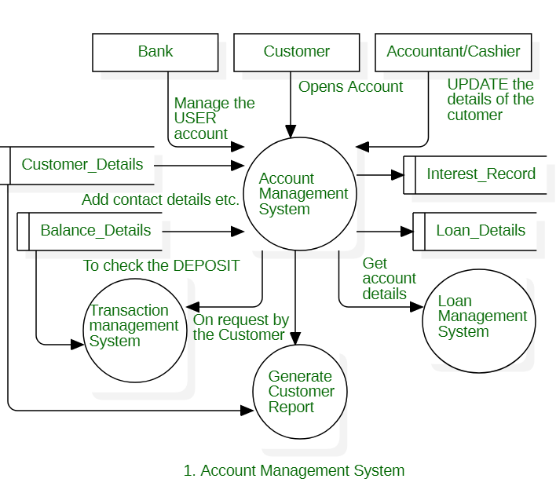

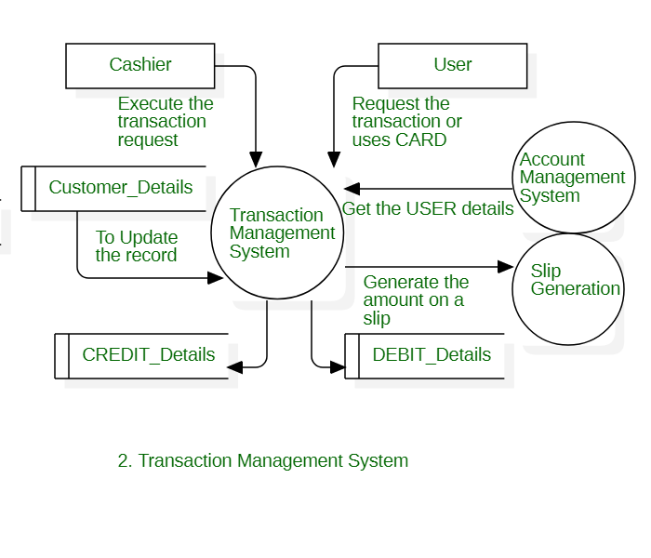

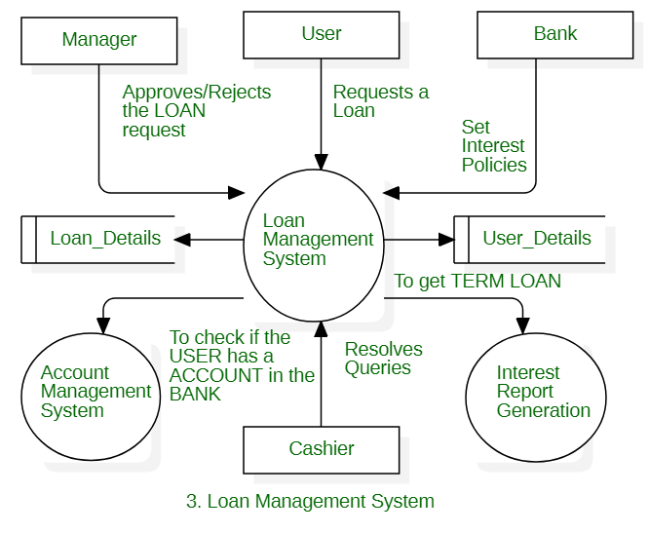

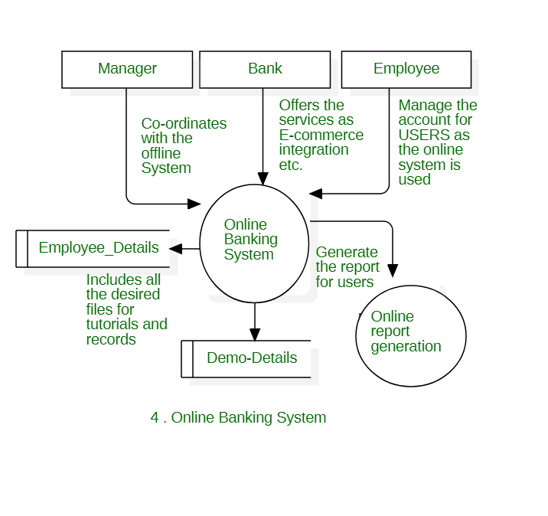

**Conclusion:**

Data Flow Diagrams are highly useful tools to maintain these aspects of the operation. They provide critical insights into the systems and ways the information passes through it. DFD helps structure every element of the system, keep them logically intact and interconnected. Thus, we have successfully sketch the DFD Diagrams for our project.

ForFacultyUse

|  |  |  |  |  |
| --- | --- | --- | --- | --- |
| **CorrectionParameters** | **FormativeAssessment[40%]** | **Timely completionofPractical[40%]** | **Attendance /LearningAttitude[20%]** |  |
| **MarksObtained** |  |  |  |